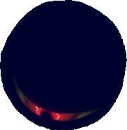

Quest: Inflict 3 creatures with a debuff, reward: -6 cost.

: (OPT) Steal 2 HP from any creature on the PF.

: -2 DEF.

Demon: +1 ATK.



Nebulous Precipice

